The Tribe Of Naphtali In The Bible
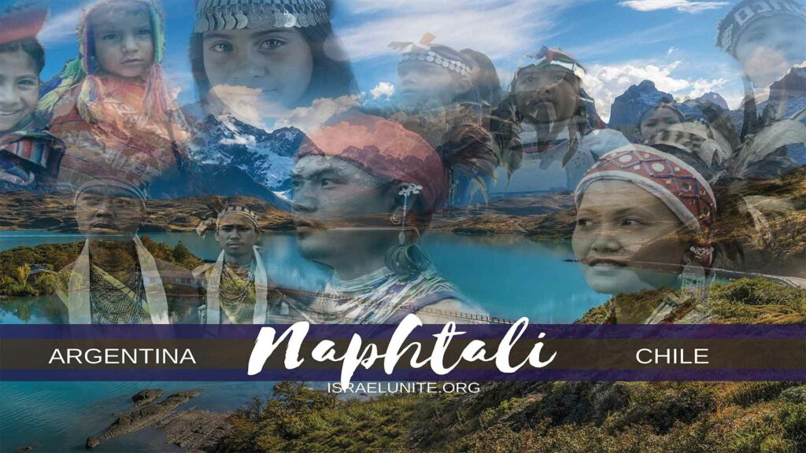
Napthtali, was the sixth born of Jacob. His name means “my wrestling”. Read Genesis 30:8. The tribe of Napthtali was included in the migration of the “Ten Tribes of Israel”, to the Americas around 536 B.C.
Genesis 49: 1 “And Jacob called unto his sons, and said, Gather yourselves together, that I may tell you that which shall befall you in the last days.” The last days occur from the days of Christ till today. Read Hebrews 1:2.
Genesis 49:21, “Napthtali is a hind let loose: he giveth goodly words.”
“Napthtali is hind let loose…” meaning as a hind (young deer) is let loose and wandereth with excitement to various areas. Likewise the tribe of Napthtali would be nomadic, travelling to various areas in Argentina and Chile. They were known as gouchos; who were famous buckers and herdsman.
Verse 21 continues, “…he giveth goodly words.” meaning they were very social and pleasant people who always gave good greetings. The capital of Argentina is “Buenos Aires” which means good air, this reflects the prophecy of Napthtali being good/pleasant people.
Deuteronomy 33:23, And of Napthtali he said, O Napthtali, satisfied with favour, and full with the blessing of the Lord, possess thou the west and the south.”
Napthtali was satisfied with favor refers to the fruitfulness of their land, such as grapes for wine and coffee beans. “Full with the blessing of the Lord…”, meaning the Most High blessed them with rich land (great for agriculture) and a huge cattle industry, which is one of the largest in the world.
Verse 23 continues, “…Possess thou the west and the south.”
Now remember, Moses was dwelling in Israel when this prophecy was spoken. The land that Napthtali inherited, was located in the northern part of Israel; so where was Moses talking about? The Heavenly Father revealed to Moses, the prophecy of what lands the tribe of Naphtali would occupy (when they migrated to the Western Hemisphere) alongside their brethren. “Possess thou the west and the south” when you look at a map, the most southern lands in the Western Hemisphere that occupy this location are Argentina and Chile.
SHALOM

